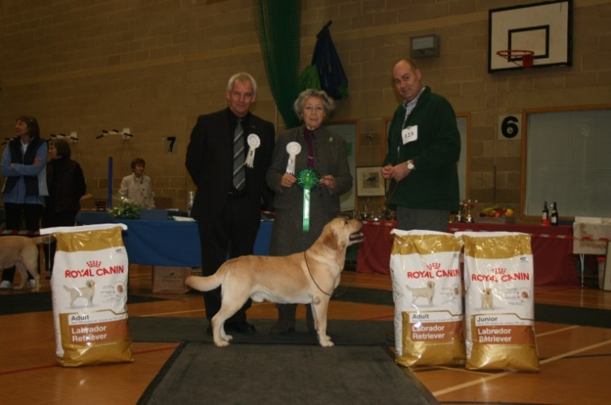
Best dog - Mrs J & Mr G Johnson - Cremino Cupids Beau

MINOR PUPPY DOG
- Edwards KIMBAJAK MANHATTAN
- Pastusiak SECRET WAY TO MY HEART OF LABGOLD
- Glen MILLROSEGLEN MAKE MY DAY
- Barker DEERBROOK ZACATE
- Harvey-Major LINJOR O’GRADY
PUPPY DOG
- Rogers WOODMIST MULBERRY
- Harvey-Major LINJOR CHOPIN JW
- Powell SEATALLAN XERULA
- Bold SHAYMILONEY SENATE
- Hynd & Johnson MAYSBORN LOVABLE ROGUE
JUNIOR DOG
- Dodd OAKHOUSE OPES AND DREAMS AT CARRRIEGAME
- Parrott LOUGIN LOKI
- Rawlinson CARPENNY MY PREROGATIVE AT HALISHIMOOR
- Jones HAFNAU ZEBEDEE
- Ellis & Matulla DOLWEN POLESTAR

DOGS: JUDGE MRS CAROLE COODE

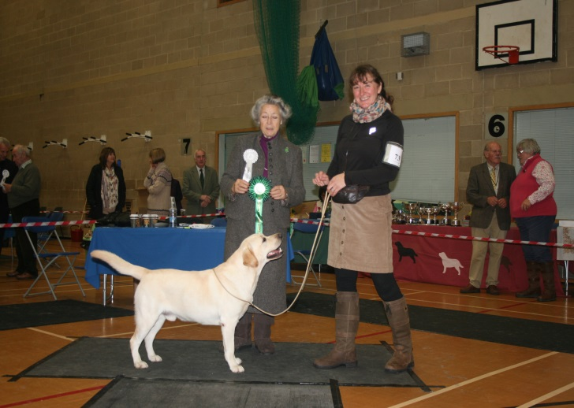
Reserve best dog - Miss L J Finney - Play On Words

SPECIAL YEARLING DOG
- Finney & Callender CARPENNY SHIP TO SHORE JW
- Floyd TRENOW RIO GRANDE JW
- Wyatt MEADOWLEIGH BROWN SUGAR
- Kerry OCEANWOOD SUNSEEKER
- Bond CARPENNY SEASHORE

MAIDEN DOG
- Rawlinson CARPENNY MY PREROGATIVE AT HALISHIMOOR
- Glen MILLROSEGLEN MAKE MY DAY
- Barker DEERBROOK ZACATE
- Harvey-Major LINJOR O’GRADY
- Van Leeuwen LINJOR CASSABLANCA

NOVICE DOG
- Edwards KIMBAJAK MANHATTAN
- Parrott LOUGIN LOKI
- Rawlinson CARPENNY MY PREROGATIVE AT HALISHIMOOR
- Glen MILLROSEGLEN MAKE MY DAY
- Harvey-Major LINJOR O’GRADY

UNDERGRADUATE DOG
- Mills LEMBAS MIKADO
- Dodd OAKHOUSE OPES AND DREAMS AT CARRRIEGAME
- Bambrook LINJOR SESSILE OAK
- Kerry OCEANWOOD SUNSEEKER
- White LUNAPET DAWN CHORUS
SPECIAL GRADUATE DOG (for handlers of 18 years and under)
No entries
GRADUATE DOG
- Finney PLAY ON WORDS
- Litherland OAKHOUSE ORLANDO BLOOM
- Powell SEATALLAN WALNUT
- Williamson SHAROUNS LIFE OF RILEY JW
- Smith SMITHTRIBELAB RED RUBIN
POST GRADUATE DOG
- Swift LEMBAS TRAVELING LIGHT BY HAMPSBECK JW
- Venturi Rose LEOSPRING GOLD GILI
- Thorpe TAPH’S TANGO JW
- Reynolds CARROMERS BLUE LAGOON
- Callender PARBUCKLE BLUE SPRUCE
LIMIT DOG
- Johnson CREMINO CUPIDS BEAU
- Braimbridge SOUTHRIDGE SKY ROCKET TO HANNABEE
- Williamson SHAROUNS INCOGNITO JW
- Floyd TRENOW PLOVER
- O’Donoghue PHILIPSTOWN BEACH BOY

OPEN DOG
- Hodge CH NAIKEN ZEPHYR JW
- Hopkinson POL CH ROCHEBY MISTER TOM
- Rawlinson SH CH FULWELL FLY HIGH TO HALISHIMOOR
- Shirton SH CH WOOLMAN CADELL JW
- Ayres MUSUBI IMPERIAL TOPAZ JW
VETERAN DOG
- Miles ATTIKONAK BUTTON UP YOUR OVERCOAT AT LLANSTINAN (IMP SWE)
- Litherland OAKHOUSE OFFICE HEAD
- Bond THORNCROSS WINDWARD
- King LINTHWAITE MAXIMUS
STUD DOG
No entries

DOG CHALLENGE CERTIFICATE CREMINO CUPIDS BEAU
DOG RESERVE CHALLENGE CERTIFICATE CARPENNY SHIP TO SHORE JW
BEST PUPPY DOG WOODMIST MULBERRY

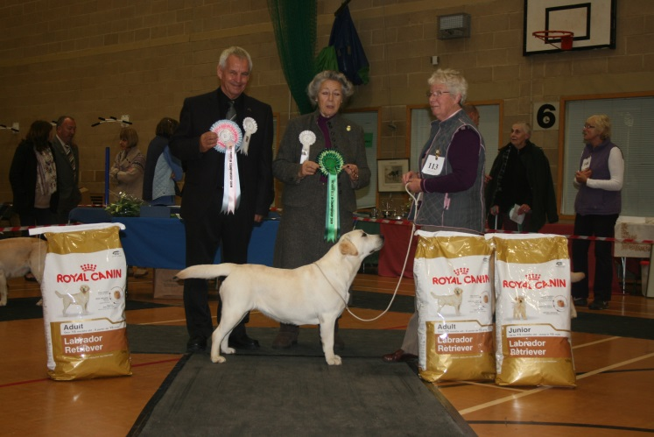
Reserve best bitch, reserve best in show & best puppy in show
Mrs D M Hopkinson - Rocheby Sensational

MINOR PUPPY BITCH
- Hopkinson KILBURNPARK MISS MAUREEN AT ROCHEBY
- Edwards KIMBAJAK LIBERTY LADY
- Reynolds CARROMERS SHIMMERING TIARA
- Lawrence VELVETINE PREHNITE AT DUNABBEY
- Ponsford BADGERSLEIGH RON DE LACE
PUPPY BITCH
- Hopkinson ROCHEBY SWEET SENSATION
- Powell SEATALLAN XERONEMA
- Taylor WOODMIST MYRTLE
- Brambles SHAYMILONEY STORMIN NORMA
- Fox SHEENARON MERRY IRON LADY
JUNIOR BITCH
- Williamson SHAROUNS NOSTALGIA JW
- Wood LOUGIN SECRET SPY AT SUNDYKE
- Bean CELTWOOD ROSE QUARTZ
- Ellis & Matulla DOLWEN STARLIGHT
- King LINTHWAITE CLEOPATRA
SPECIAL YEARLING BITCH
- King LINTHWAITE LOUISIANA
- Shirton WOOLMAN PROPER FANCY FREE
- Van Leeuwen DUTCH CH SALLYJO’S WICKED
- Reynolds CARROMERS HOT OFF THE PRESS JW
- Hodge NAIKEN ALIZE

BITCHES: JUDGE MR DAVID WILMSHURST

MAIDEN BITCH
- Hopkinson ROCHEBY SENSATIONAL
- Britton BOWSTONES GOOD DAY SUNSHINE
- Brambles SHAYMILONEY STORMIN NORMA
- Beer TARKABBY GEORGIA
- Edwards KIMBAJAK LIBERTY LADY
NOVICE BITCH
- Parrot LOUGIN LYIN’ EYES
- Bean CELTWOOD ROSE QUARTZ
- Ellis & Matulla DOLWEN STARLIGHT
- Frazer SILMARILLION LADY LUTHIEN
- Fox SHEENARON MERRY IRON LADY
UNDERGRADUATE BITCH
- Parrot LOUGIN LYIN’ EYES
- Roberts CAMBREMER STARLIGHT OVER KILLANOW
- Williamson ENELEON EASY DOES IT FOR SHAROUNS
- Ellis & Matulla DOLWEN STARLIGHT
- King LINTHWAITE LOUISIANA

SPECIAL GRADUATE BITCH (for handlers of 18 years and under)
- Mills TRENDLEWOOD SING AT JAYBEC

GRADUATE BITCH
- Powell SEATALLAN WATERLILY
- Parrott LOUGIN LONA
- Johnson CREMINO COBNUT
- Rooth CHELONIA THOUSAND GUINEAS AT GREENWORTH
- Schopen LEJIE SONG OF SUMMER
POST GRADUATE BITCH
- Jones HAFNAU ANASTASIA
- Parrott LOUGIN LAMAZE
- Dodd CAMBREMER SUMMER BREEZE AT CARRIEGAME
- Hopkinson ROCHEBY SMALL TALK
- Thorpe TAPH’S SALSA
LIMIT BITCH
- Ellis & Matulla TRENOW PRIMROSE AT DOLWEN
- Dodd BROCKBURROW BREAKING DAWN
- Shirton WOOLMAN PROPER STARLIGHT
- Frazer LINDALL RAZZLEDAZZLE AT SILMARILLION
- O’Donaghue PHILIPSTOWN OCEAN WAVE
OPEN BITCH
- Woodburn SH CH CENTENALEE SPARKLING SNOW
- O’Donoghue IR SH CH PHILIPSTOWN ATLANTIC BREEZE
- Beer TARKABBY EMBRACE
- Mills SH CH LEMBAS MAMMA MIA JW
- Harvey Major LINJOR RHIANNA JW SHCM
VETERAN BITCH
- Rogers WOODMIST SAFFRON
- Hodge LINDALL NADIA AT NAIKEN JW
- Phillips SHARDANEL BLUERIBBON AT SHEENARON
- Mills TRENDLEWOOD SING AT JAYBEC
BROOD BITCH
- Rogers WOODMIST SAFFRON
- Barker CARPENNY YEVA GYDA DEERBROOK

BITCH CHALLENGE CERTIFICATE WOODMIST SAFFRON
BITCH RESERVE CHALLENGE CERTIFICATE ROCHEBY SENSATIONAL
BEST PUPPY BITCH ROCHEBY SENSATIONAL

BEST IN SHOW WOODMIST SAFFRON
RESERVE BEST IN SHOW ROCHEBY SENSATIONAL
BEST OPPOSITE SEX CREMINO CUPIDS BEAU
BEST PUPPY IN SHOW ROCHEBY SENSATIONAL
BEST VETERAN IN SHOW WOODMIST SAFFRON

